**Setu Center Registration**

* Home page -> Registration Page Link

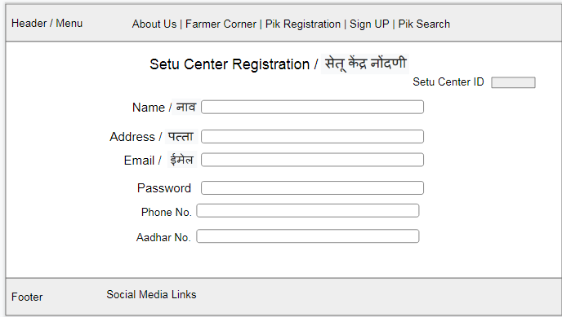

* Parameters :

1. Name:
2. First Name : Validation Input type: Text
3. Middle Name : Validation Input type: Text
4. Last Name : Validation Input type: Text
5. Address :
6. Email : Validation Input type : Email
7. Password: Set a Password
8. Phone no. : Input type number
9. Aadhar No. : Input type number
10. Documents: Address Proof, Pan no. ,etc

* Generates Temporary Setu Center ID and Applied for License
* Verification Process
* License and Setu Center ID Generation
* Sign In Page for Setu Center

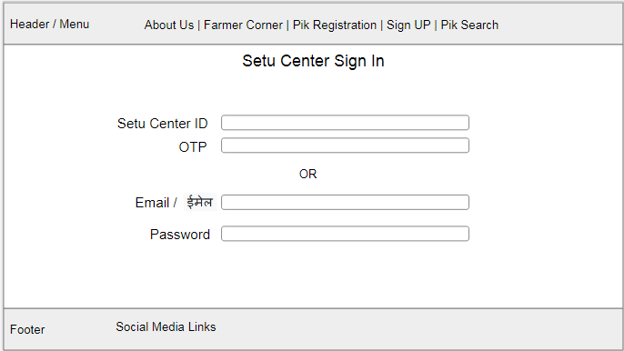

* Dashboard

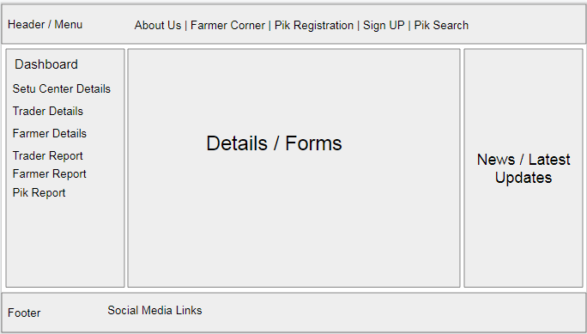

1. Setu Center Details : Details/ Update details / Remove
2. Trader Details: CRUD Operations
3. Farmer Details: CRUD Operations
4. Trader Report: Trader Report , % of traders in particular area,etc
5. Farmer Report: % of farmers who grow a particular crop,etc
6. Pik Report: Bar charts and pie charts of crops